**Report on Student Grade Management Program**

**Introduction:**

The Student Grade Management Program is designed to efficiently manage student details, calculate CGPA (Cumulative Grade Point Average), and determine departmental ranks based on CGPA. This program allows users to input student information, store it, retrieve details, and calculate relevant metrics.

**Functionality:**

**It helps us to store the CGPA and Departmental rank of a student based on the grades and**

**Welcome Message:**

Upon launching the program, users are greeted with a welcome message explaining the functionalities and guidelines for inputting department codes and names.

**Storing Student Details:**

Users can input student details such as roll number, name, department, study year, number of semesters completed, and subject information (name, credits, and grade). The program stores this information in memory.

**CGPA Calculation:** After entering subject details, the program calculates the CGPA of the student based on the grades and credits obtained in each subject.

**Departmental Rank Calculation:**

It calculates the departmental ranks of students based on their CGPA within the same department.

**Saving and Loading Student Details:**

The program can save student details to a CSV file ("Student.csv") and load previously stored details from the same file, ensuring persistence of data (Departmental rank and cgpa) across program executions.

**Displaying Student Details:**

Users can retrieve and display individual student details by entering the student's roll number.

**Displaying Departmental Ranks:**

Users can view the departmental ranks of all students within their respective departments.  
  
This program is written in C and requires a C compiler to build and execute.

**Standard libraries such as stdio.h, stdlib.h, and string.h are utilized.**

**Ensure the provided constants, such as MAX_stud and MAX_sub, are appropriately configured based on system requirements and constraints.**

**Make sure the CSV file "Student.csv" is accessible and writable by the program.**

**Acknowledgments:**

This program was developed to streamline student data management and facilitate efficient analysis of academic performance. It serves as a versatile tool for educational institutions and administrators seeking to organize and evaluate student records effectively.

**Contributions and Feedback:**

Contributions to this project are welcome via pull requests. If you encounter any issues or have suggestions for improvement, please feel free to open an issue.

Name: Bhargav Shekokar  
Roll Number: B23CS1008  
Batch: B6

**Sample Input-Output:**

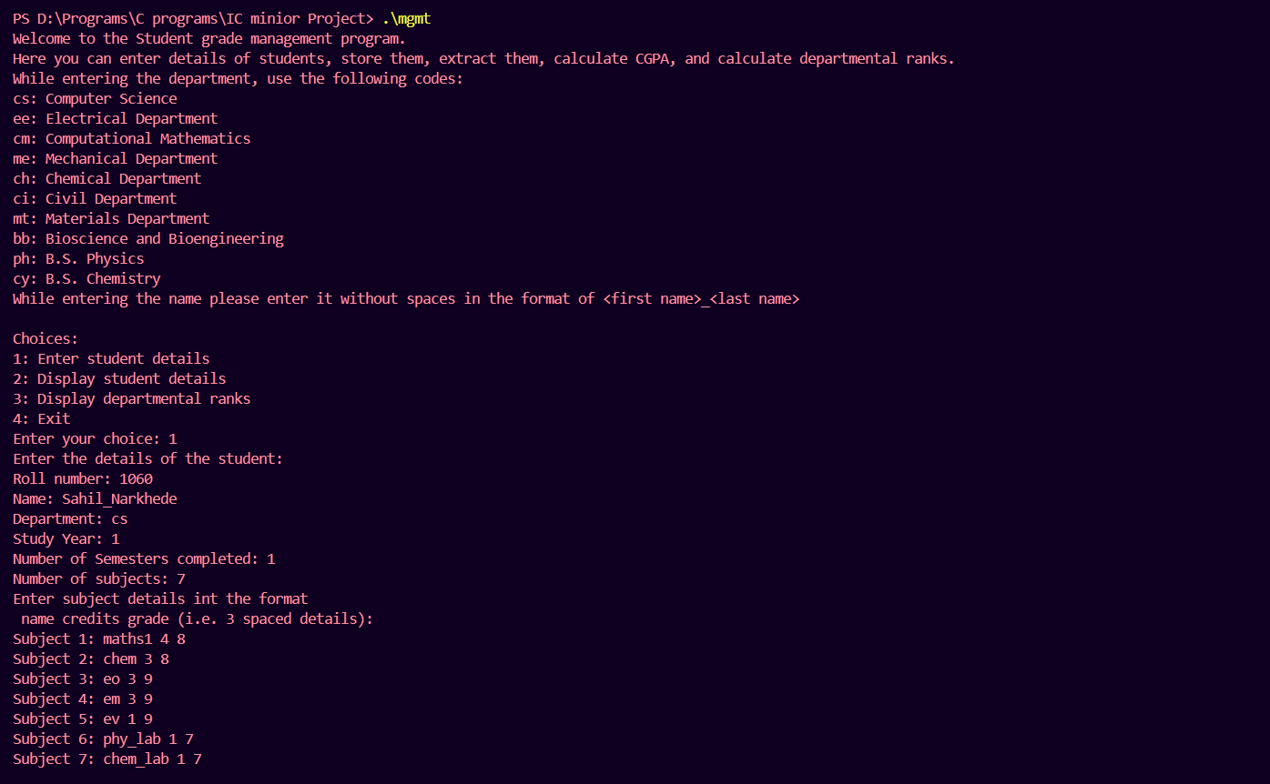

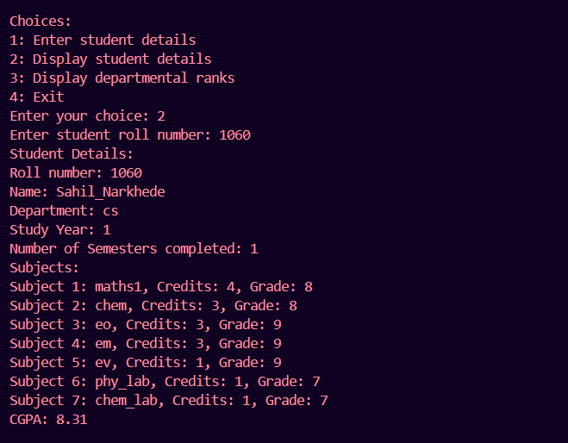

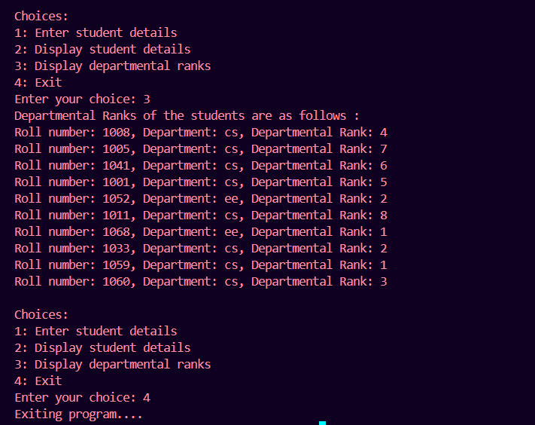

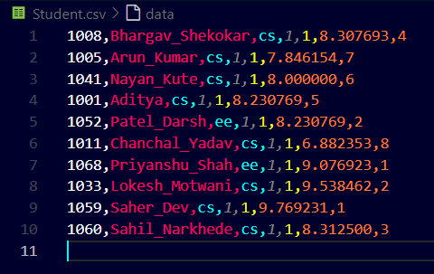

**Input : 2**

